

Curriculum Design for Science and Maths Sub-Topics aligned to CBE Grade 10
Scheme of Work for

Subject: Biology
Strand / Topic: # and Name 2.0 Anatomy and physiology of plants
Sub-strand / Sub-Topic: # and Name 2.1 Gaseous exchange and respiration
Author: Jackline Mwambere

Curriculum Design: The lesson/unit is designed for students to make sense of phenomena and/or design solutions to problems by engaging in student sense making

Learning Outcomes:
Relate structure of chloroplast to its function in plant cell
Illustrate light and dark stage of photosynthesis in plants
Appreciate the significance of photosynthesis in nature

Chapter and/or Unit Criteria  Lessons and units designed so students make sense of a phenomenon-based storyline and/or design solutions to problems.  The design of this unit/chapter includes: | Use Khan or Rachel or Internet to help you identify useful tools | SENSE-MAKING  - Providing strategies for ensuring student sense-making and/or problem-solving about each lesson.  - Which sense-making tools will you use with each of the lessons you are building into your plan? | FORMATIVE ASSESSMENT:  - Find sample assessments in Rachel or Khan to use.  - Embeds formative assessment opportunities throughout that evaluate student learning to inform instruction.  - Provides multiple opportunities for students to demonstrate their understanding the content and receive feedback
- THE PHENOMENON: Making sense of phenomena and/or designing solutions to a problem drive student learning.  - The phenomenon is current, relevant, real world that can be answered by using science principles, computational skills and/or engineering design solutions.  - The phenomenon is observable and interesting to students. Something they want to figure out.  - The phenomenon is framed as a Driving Question to be figured out in the series of evidence gathering activities  - Student questions and prior experiences related to the phenomenon or problem motivate sense-making and/or problem solving.  - Students show their initial thinking by drawing a model. | - Present the phenomenon/story TIME LAPSE FOR GROWING GIANT PUMPKIN. HERE  Driving questions: How do plants get their nutrients? What role does sunlight play? | Ask students what they think plants need to survive. Let them writeon post it notes or their exercise books  Based on video in time lapse how do they think the pumpkin obtained its nutrient to grow bog | Students braisntorm  Driving question board  What i know What i have learned What i questions do i have  Students draw their initial models
PREPARE A MODEL SCAFFOLD
- A place for students to draw, write, discuss their initial ideas about the phenomenon
- Driving Question Board as an option to collect students’ initial ideas and questions after they draw their initial model.
PLAN FOR DRAWING UPON STUDENTS’ PRIOR KNOWLEDGE

Includes suggestions for how to connect instruction to the students' home, neighborhood, community and/or culture as appropriate.
  - Provides opportunities for students to connect their explanation of a phenomenon and/or their design solution to a problem to questions from their own experience.

Chapter and/or Unit Criteria  Lessons and units designed so students make sense of a phenomenon-based storyline and/or design solutions to problems.  The design of this unit/chapter includes: | Use Khan, Rachel, SV for Teachers, LabXchange, or Internet to help you identify useful tools  Provide Links to Supporting Documents Found on Rachel or Internet | SENSE-MAKING  - Providing strategies for ensuring student sense-making and/or problem-solving about each lesson.  - Which sense-making tools will you use with each of the lessons you are building into your plan?  - Teacher moves | FORMATIVE ASSESSMENT:  - Find sample assessments in Rachel or Khan to use.  - Embeds formative assessment opportunities throughout that evaluate student learning to inform instruction.  - Provides multiple opportunities for students to demonstrate their understanding the content and receive feedback
LESSON SEQUENCE  - Give a general outline of the lessons that will be used to teach this topic | Lesson 1: Introduction to the Phenomenon  - Present the phenomenon/story: Show a video time lapse for growing a pumpkin.  - Ask students what they think plants need to survive.  - Set the driving questions: How do plants get their nutrients? What role does sunlight play?  Lesson 2: Exploring Types of Nutrition in Plants  - Investigate autotrophic vs. heterotrophic nutrition.  - Connect to the phenomenon: How might nutrition differ by environment?  Lesson 3: Meet the Chloroplast — Plant’s Solar Powerhouse  - Investigate chloroplast structure and function.  - Relate structure to function as plants adapt to capture sunlight.  Lesson 4: Photosynthesis Begins — The Light Stage  - Explore the light-dependent reactions.  - Hands-on: Observe oxygen bubbles from aquatic plants under light.  Lesson 5: Photosynthesis Continues — The Dark Stage  - Learn about the Calvin cycle.  - Interactive card sequencing connects reactions.  Lesson 6: Factors necessary for photosnthesis  - Experiments investigating factors necessary for photosynthesis.  Lesson 7: How Environment Affects Photosynthesis  - Examine factors (light, temperature, CO2).  - Students hypothesize how plants in different environments adapt photosynthesis.  Lesson 8: Heterotrophic Plants — When Photosynthesis Isn’t Enough  - Investigate carnivorous, parasitic plants.  - Story connections about survival in harsh environments.  Lesson 9: Significance of Photosynthesis in Nature  - Connect photosynthesis to the food chain and oxygen supply.  - Discuss human reliance on plants.  Lesson 10: Research and Collaboration  - Small groups investigate different plant adaptations linked to nutrition.  - Present findings in story format.  Lesson 11: Synthesis — Creating the Plant Survival Story  - Students create a storyline showing how plants survive and thrive using nutrition mechanisms.  - Use visuals, charts, or digital storyboards.  Lesson 12: Reflection, Assessment, and Extension  - Reflect on how knowledge of plant nutrition solves the phenomenon.  - Quiz and group discussion.  - Explore further questions or related phenomenon
- THE EVIDENCE GATHERED: What are the lessons you will use in your class to help your student collect evidence to answer the Driving Question/ figure out the phenomenon?  - Provides at least 4 opportunities to gather evidence through (readings, practicals, simulations, videos)  - The focus of each lesson is to support students in making sense of phenomena and/or designing solutions to the problems and prior student experiences.  - Each lesson builds on prior lessons by addressing questions raised in those lessons, cultivating new questions that build on what students figured out, or cultivating new questions from related phenomena.  - Provides strategies for linking student engagement across lessons (revisit the model and add to the model as evidence is gathered and students figure it out). | Lesson 2: Exploring Types of Nutrition in Plants  - Investigate autotrophic vs. heterotrophic nutrition.  - Connect to the phenomenon: How might nutrition differ by environment?  Lesson 3: Meet the Chloroplast — Plant’s Solar Powerhouse  - Investigate chloroplast structure and function.  - Relate structure to function as plants adapt to capture sunlight.SIMULATION  Lesson 4: Photosynthesis Begins — The Light Stage  - Explore the light-dependent reactions.  - Hands-on: Observe oxygen bubbles from aquatic plants under light.  - Reading HERE  Lesson 5: Photosynthesis Continues — The Dark Stage  - Learn about the Calvin cycle.  - . Reading Here  Lesson 6: Factors necessary for photosnthesis  - Conduct experiments on factors necessary for photosynthesis  Lesson 7and 8: How Environment Affects Photosynthesis  - Examine factors (light, temperature, CO2).  - Students hypothesize how plants in different environments adapt photosynthesis  Video HERE  Lesson 9: Heterotrophic Plants — When Photosynthesis Isn’t Enough  - Investigate carnivorous, parasitic plants.  - Story connections about survival in harsh environments.  Lesson 10: Significance of Photosynthesis in Nature  - Connect photosynthesis to the food chain and oxygen supply.  - Discuss human reliance on plants. | Lesson 2: Exploring Types of Nutrition in Plants  Teacher:  Introduces autotrophic and heterotrophic nutrition by providing photos showing different modes of feeding in plants.  Provides reading HERE and facilitates discussion on plant nutrition types.  Guides students to connect nutrition types to different environments.  Students:  Observe photographs HERE showing different modes of feeding  Participate in discussions by sharing ideas on how plant nutrition might vary with the environment based on reading and photographs observed.  Lesson 3: Meet the Chloroplast — Plant’s Solar Powerhouse  Teacher:  Presents detailed diagrams and explains chloroplast structure.  Demonstrates or uses simulation HERE showing chloroplast function.  Facilitates discussion on how structure relates to function in sunlight capture.  Students:  Students figure out the function of chloroplast and factors necessary for photosynthesis from the simulation. . HERE  Discuss in groups of four the observations made and come to consensus on their explanation. Then present their findings to class.  Draw and Label chloroplast parts on worksheets.  Reading. HERE Discuss in pairs how chloroplast structure supports photosynthesis  Lesson 4: Photosynthesis Begins — The Light Stage  Teacher:  Explains light-dependent reactions and photolysis.  Sets up and supervises hands-on experiments observing and testing oxygen bubbles from aquatic plants under light.  Asks guiding questions during the experiment.  - What would happen if you removed water or carbon dioxide from the experiment? Why?  - What is the role of chlorophyll in photosynthesis?  - How do the observations from your experiment support or contradict your hypothesis?  - Why do plants produce oxygen during photosynthesis, and how does that affect the environment?  Students:  Conduct the experiment observing gas released.  Test the gas produced to confirm its identity.  Relate the gas production to the light stage of photosynthesis.  Lesson 5: Photosynthesis Continues — The Dark Stage  Teacher:  Provides reading for groups of four students on the Calvin cycle and its role in photosynthesis.  Guide students on what to look for when watching the video HERE  Students:  Watch videos using chrome books at their pace. And discuss in pairs their findings on the dark stage of photosynthesis.  Lesson 6: Factors necessary for photosnthesis  Teacher:  Demonstrates using experiment factors necessary for photosynthesis.  Guides students through the experiment setup. Use the simulation HERE  Students:  Conduct experiments given in the students book/ use simulation to show how different factors affect the rate of photosnthesis  Observe and record .Draw graphs and anaylse them  Lesson 7 and 8: How Environment Affects Photosynthesis  Teacher:  Discuss how light concentration, carbon (IV) oxide, and temperature affects the rate of photosynthesis  Explains factors affecting photosynthesis.  Encourages students to hypothesize plant adaptations to different environments.  Students:  Formulate hypotheses in groups.  Share ideas in class discussion.  Possibly design simple experiments or case studies on environmental effects.  Lesson 9: Heterotrophic Plants — When Photosynthesis Isn’t Enough  Teacher:  Introduces carnivorous and parasitic plants.  Tells stories/examples of these plants adapting to harsh environments.  Students:  Listen and take notes.  Participate in storytelling or role-play.  Research one type of heterotrophic plant and share findings.  Lesson 10: Significance of Photosynthesis in Nature  Teacher:  Explains photosynthesis’ role in food chains and oxygen supply.  Facilitates a discussion on human reliance.  Students:  Engage in class discussion.  Watch short videos/documentaries. HERE  Reflect on photosynthesis importance through written or oral responses.  Project  Teacher:  Assigns small groups to investigate specific plant adaptations related to nutrition.  Supports research efforts and guides storytelling presentations.  Students:  Collaborate in groups to research and write an essay on how plants are adapted to photosynthesis.  Prepare and present findings as stories using visuals or digital tools.  Provide peer feedback. | Complete a short worksheet or quiz distinguishing the types of nutrition.  HERE  Label chloroplast parts on worksheets and relate parts to functions .  Review models here indicating inputs and outputs of photosynthesis.  Put some new learning on the driving question board.  Asks guiding questions during the experiment.  - What question are you trying to answer in this experiment?  - What do you think plants need to carry out photosynthesis?  - What are the inputs and outputs of photosynthesis?  - Where in the plant does photosynthesis occur?  - How do you think light intensity affects the rate of photosynthesis?  - What differences do you observe between plants exposed to light and those kept in the dark?  Students revise initial models and driving question board  Review the initial diagrams  Fill in the collumn of what i have learned in the driving question board  Relate the video observed previously with the experiment done to see connections  Analysis of graphs drawn and relating to the phenomenon.  Revisiting the driving question board and revision of initial  Project  Small groups investigate different plant adaptations linked to nutrition.  Present findings in story format
PLAN FOR THE SUMMARY TABLE HERE  - Create the summary table template here which includes the lesson title, a description of what was learned, and a place to reflect on how the lesson helps to explain the phenomenon. | 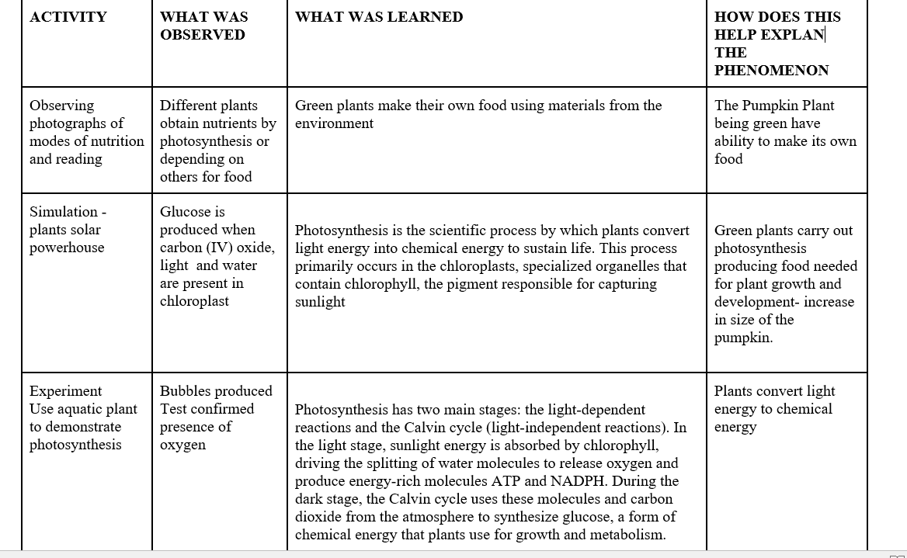
- FINAL EXPLANATION:  What will students be able to explain when they are finished with the Unit/Chapter?  Expectation for the final explanation: (citing evidence gathered that helps explain the scientific principles for this chapter/unit)?  Write out the final explanation here.  - Uses scientifically accurate and grade- appropriate scientific information to explain the phenomena | Revisit the Driving questions to identify what evidence students have gathered to help them answer the questions. | What is the plan for helping students write this final explanation? (Use their final Model. Summary Table.)  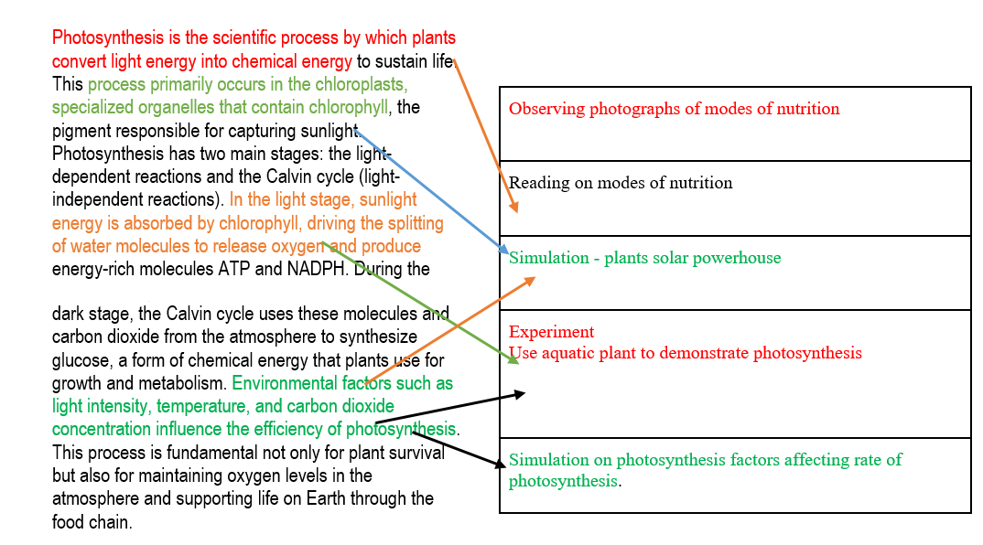

CBE REQUIREMENTS REFERENCED IN THIS UNIT | Clearly articulate how these topics are addressed in this unit
Core competencies* (digital literacy, citizenship, learning to learn, collaboration/communication, critical thinking/problem solving, self-efficacy, imagination/creativity) addressed in this Curriculum Design | The students will develop digital literacy as they use the chromebooks to watch videos, use simulations and interactives,, learning to learn as they will earn how to learn using the graphs and simulations, collaboration/communication will be developed as they work in groups, critical thinking/problem solving, self-efficacy will be developed as they analse graphsand revise the models landfill the summary table and writing down the final explanation. ,
Which Core Values** are addressed? (Nationalism and patriotism, Respect, Responsitillity, Integrity, Peace and Social Justice, Love, Unity, Excellence, Care and Compassion, Tolerance, Ethics) (do this by using Norms?) | The Core Values addressed are Respect as students respect other opinions, Responsitillity as they do the experiments handling apparatus responsibly, Unity as they wor in groups, Care and Compassion for plants when they learn importance of plants on the earth. ,
Which pertinent and contemporary issues are/ or could be addressed in this scheme of work? | Global warming. Environmental conservation
Are there careers that might use this knowledge | Plant care, enviromentalist
Do we need to create Rubrics for any of the embedded assessments? If so list those here: | Yes, for the final explanation

*CORE COMPETENCIES:
- Communication and Collaboration:.
- Emphasizes the ability to effectively communicate ideas and work with others.
- Self-efficacy:.
- Focuses on building learners' confidence and belief in their ability to succeed.
- Critical Thinking and Problem Solving:.
- Encourages learners to analyze information, solve problems, and make informed decisions.
- Digital Literacy:.
- Develops the skills to effectively and safely use technology and digital tools.
- Learning to Learn:.
- Fosters a mindset of continuous learning and the ability to acquire new knowledge and skills independently.
- Citizenship:.
- Promotes an understanding of civic responsibilities and active participation in society.
- Creativity and Innovation: .
- Encourages learners to think creatively, generate new ideas, and find innovative solutions.

**CORE VALUES:
- Nationalism and Patriotism: Instilling a sense of national unity, identity, and pride in Kenya.
- Respect: Fostering respect for oneself, others, and cultural diversity.
- Responsibility: Developing a sense of responsibility towards oneself, the community, and the environment.
- Integrity: Promoting honesty, ethical behavior, and moral principles.
- Peace and Social Justice: Encouraging harmonious coexistence and equitable treatment of all.
- Love: Creating a supportive and caring learning environment.
- Unity: Promoting togetherness and social cohesion.
- Excellence: Striving for high standards in all endeavors.
- Care and Compassion: Developing empathy and concern for the well-being of others.
- Tolerance: Fostering understanding and acceptance of different perspectives.
- Ethics: Instilling a strong moral compass and ethical decision-making.

